MEGA BLOOD DONATION DRIVE

The Mega Blood Donation Drive event was successfully organized by the NSS unit of SSN on 17th September 2025 from 9:30 AM to 2:30 PM at the Mini auditorium. Organized by Malathi, Dinesh, Siddharth Chandrasekar S Ganesh and Vishnu Kumar, the drive aimed to encourage students and staff to come forward and contribute towards saving lives by donating blood.
- Date: 17th September 2025
- Time: 9:30 AM – 2:30 PM
- Venue: Mini Auditorium, SSN
- Organized by: NSS Unit of SSN

A total of 25 volunteers actively participated in the Mega blood donation drive. To ensure effective coordination, the volunteers were divided into groups of three, for each operation to assist under guidance of the hospital doctors and staffs. The event saw active participation from students, faculties and staff members. Each donor was accompanied and guided by medical professionals and NSS volunteers to ensure a safe and smooth process. Donors were checked by the doctors about their ability to donate and were made aware about the health benefits of regular blood donation.

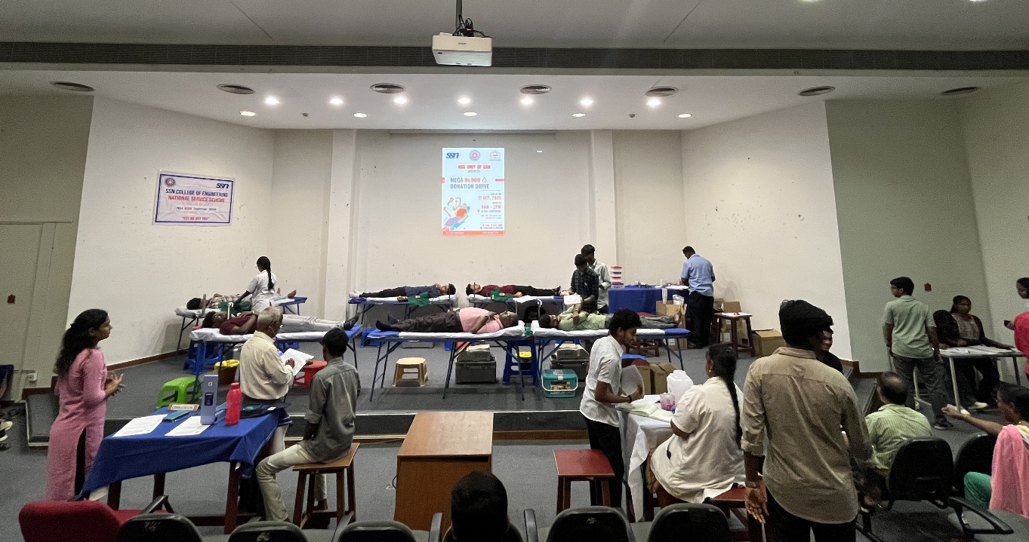
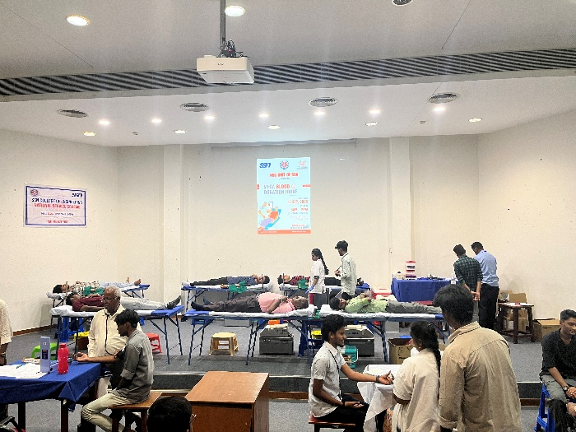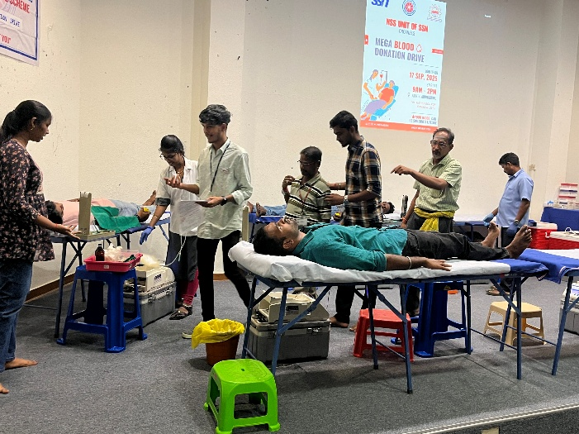
Around 72 number of donors came forward to donate blood. The objective of the event was to instill the spirit of service and responsibility towards society. The health condition of the donors (BP, hemoglobin level) was reviewed by doctors before donation to ensure their safety. Donors were provided with refreshments after donation. NSS volunteers stood by each donor right from registration to donation at each step. The event strengthened the values of empathy, responsibility, and social service among participants.
The donors registered themselves before donation and every donor was provided with E-Certificate for their social service and the spirit of compassion.
We extend our heartfelt gratitude to all donors and NSS volunteers for their valuable contributions. Together, we have taken a meaningful step toward creating a healthier society and a true spirit of compassion.

